LAB

Variable

Lab Java – Variables

Objective
In this lab you will:
- Declare and initialising variables.
- Practice using mathematical operators.

Part 1 – Declaring and initialising local variables.

Step by step.
- Create a new project using eclipse
- Add a new class called Program with a package called theBasics with a main( ) method to hold the following code.

- Declare and set variables (int, double, Boolean, String) to hold these details about a customer:
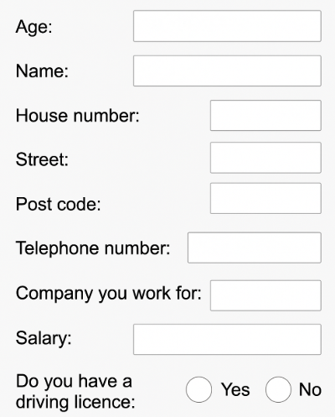
- Use a series of println (or a single one) to display the above information.
Tip: You can put variable together inside a println() using the + operator.

Part 2 – Doing some maths work.
- Expand the main method.
- Comment all the code you wrote in Part 1.
Tip: Highlight the code and press Ctrl-/
- Copy and paste the code below and carryout the tasks.
Please try one task at a time, save and run your code to test your code at every step.
System.out.println("Initial Value: " + number);
int number = 5;
// Task 1
// - double it using the '*' operator
// - now double it again using the '*=' operator
System.out.println("\n1. After doubling it twice: " + number);

// Task 2
// - add 3 to it using the '+' operator
// - now add 3 to it using the '+=' operator
System.out.println("\n2. After adding 3 twice: " + number);

// Task 3 - subtract 12 from it using an appropriate 'compound' operator
System.out.println("\n3. After subtracting 12: " + number);

// Task 4 - divide the number (ought to be 14 now) by 3
// what do you think the answer is
System.out.println("\n4. After dividing by 3: " + number);

// Task 5 write 4 different statements that all do the same thing
// namely 'add 1 to the number'
System.out.println("\n5. After adding 1 four times: " + number);

// Task 6 decrement by 1 the value of number
System.out.println("\n6. After decrementing once: " + number);
// Task 7 put the remainder when dividing by 3 into 'remainder'
int remainder = 0;
System.out.println("\n7. Remainder when dividing by 3 is :" + remainder);

// Task 8
// decide what it will print before uncommenting the println()

int a = 2, b = 3, c = 5;
double d1, d2, d3, d4;

d1 = a + b * c / 2;
d2 = (a + b * c) / 2;
d3 = (a + b) * c / 2;
d4 = (a + b) * (c / 2);
// System.out.println("\n8. Values: " + d1 + " : " + d2 + " : " + d3
// + " : " + d4);
// Type your answer here-->
// Task 9

int p, q;
p = 10;
q = 10;
p += q++;

// Decide what the next line will print
// System.out.println("\n9. Result is: " + (p + q));
// Answer-->

// Task 10 – Uncomment the code below
//System.out.println("\n11.");

// Decide what the following 4 lines will print
// The 4th one might surprise you

// System.out.println("fred" + 3 + 4); // Answer-->
// System.out.println(3 + 4 + "fred"); // Answer-->
// System.out.println("" + 3 + 4); // Answer-->
// System.out.println(3 + ' ' + 4); // Answer-->

** End **

